**Experiment 1**

Objective: Design copper straight and crossover cable from UTP(Unshielded Twisted Pair) CAT-5 or CAT-6. To learn handling and configuration of networking hardware like RJ connectors, CAT-6 cable, crimping tool etc.

**Experiment 2**

Objective: Design the network topologies to transfer PDU

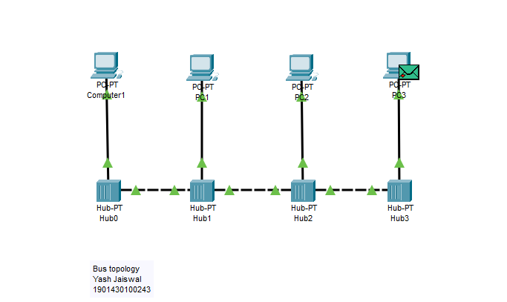

**Experiment 3**

Objective:

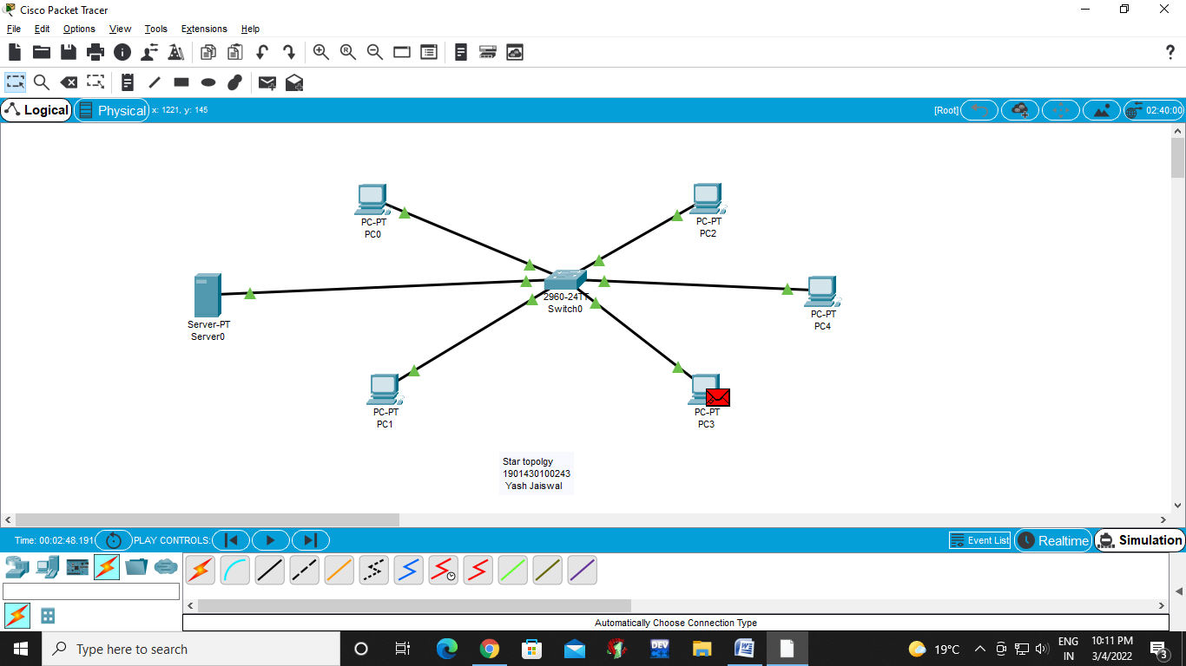

Server configuration for DHCP for wireless network

